
RANI LAXMI BAI MEMORIAL SCHOOL
RANI LAXMI BAI MEMORIAL SCHOOL
RANI LAXMI BAI MEMORIAL SCHOOL

BONAFIDE CERTIFICATE

This is to certify that Niyati singh is a bonafide student of class XII-C1 of Rani Laxmi Bai Memorial School C- Block, Indira Nagar, Lucknow in the session 2025-26.

Principal’s Sign

Subject Teacher’s Sign

External Examiner’s Sign

ACKNOWLEDGEMENT
I have taken efforts in this project titled‘LIBRARY REDCORD MANAGEMENT SYSTEM’. However, it would not have been possible without the kind support and help of many individuals and organizations. I would like to extend my sincere thanks to all of them.
I am highly indebted to our Subject Teacher Mrs.Ruchira Pandey Ma’am for her guidance and constant supervision as well as for providing necessary information regarding the project & also for her support in completing the project.

I would like to express my special gratitude and thanks to our school Director Mrs. Nirmal Tandon Ma’am and our school Principal Mrs. Manjula SethMa’am for giving me such a wonderful opportunity.

My thanks and appreciations also go to my parents& friends for their kind co-operation and encouragement which helped me in completion of this project.

NIYATI SINGH
INDEX

SNO | CONTENT
1 | INTRODUCTION
2 | HARDWARE AND SOFTWARE RESOURCES USED
3 | DATA DICTIONARY
4 | PROGRAM DESCRIPTION
5 | USER DOCUMENTATION
6 | CODING
7 | PROGRAM OUTPUT SCREEN SHOTS
8 | CONCLUSION
9 | BIBLIOGRAPHY

INTRODUCTION
The purpose of this project is to provide

RESOURCES USED

HARDWARE RESOURCES:

System Type :64-bitOperating System
CPU Type :12th Gen Intel(R) Core(TM) Main Processor : i5-1235U
CPU Clock Speed : 1.30 GHz
Installed RAM : 8 GB
Printer : Inkjet/Laser Printer

SOFTWARE RESOURCES:

Operating System : Windows 11 Pro
Programming Language : Python 3.7
IDE : IDLE
Word Processing Software : MS-Word

DATA DICTIONARY
CSV

PROGRAM DESCRIPTION

PACKAGES IMPORTED
- import pandas
- import matplotlib
- import numpy

BUILT IN/MODULE FUNCTIONS USED:-
[1]print():- to display specific output
[2]head():-to fetch given number of values from the top of dataframe.
[3]tail():-to fetch given number of values from the bottom of the dataframe.
[4]drop():-to delete a row or a column of a dataframe.
[5]rename():-to rename a row or column of a dataframe.
[6]plot():-to plot a line chart.
[7]xlabel():-to give a title to the x-axis of the chart.
[8]ylabel():-to give the title to the y-axis of the chart.
[9]title():-to give a title or heading to the chart.
[10]show():-to display the chart.
[11]grid():-to add a grid to the chart.
[12]legend():-to specify the legend for the chart
[13]bar():-to plot a vertical barchart
[14]barh():-to plot a horizontal barchart.
[15]pie():-to plot a pie chart.

ATTRIBUTES USED:-
[1] loc
[2] iloc
[3] axis
[4] linestyle
[5] linewidth
[6] marker
[7] label
[8] color
[9] width
[10] labels

FUNCTIONS USED:-
[1] write_data() :..to write data in a csv file
[2] read_data():..to read the data in a csv file

USER DOCUMENTATION
Step-1:-the first page shows the main menu.
Step-2:-when the user enter any number he would be able to perform the functions from the menu.
Step-3:-when the user enter ‘1’ then he would be able to print number of rows and columns.
Step-4:- when the user enter ‘2’ then he would be able to access rows .
Step-5:- when the user enter ‘3’ then he would be able to access columns.
Step-6:- when the user enter ‘4’ then he would be able to access individual values.
Step-7:- when the user enter ‘5’ then he would be able to add or remove a column .
Step-8:- when the user enter ‘6’ then he would be able to remove a column and a row.
Step-9:- when the user enter ‘7’ then he would be able to rename a column or a row
Step-10:- when the user enter ‘8’ then he would be able to display the sum
Step-11:- when the user enter ‘9’ then he would be able to display the max/min value of a column
Step-12:- when the user enter ‘10’ then he would be able to display the dataframe after interchanging row and column heads.
Step-13:- when the user enter ‘11’ then he would be able to sort the dataframe on basis of rows and columns.
Step-14:- when the user enter ‘12’ then he would be able to display the sum.
Step-15:- when the user enter ‘13’ then he would be able to change row/column labels.
Step-16:- when the user enter ‘14’ then he would be able to display the total number of games.
Step-17:- when the user enter ‘15’ then he would be able to display the names of all games.
Step-18:- when the user enter ‘16’ then he would be able to display row indexes and column labels.
Step-19:- when the user enter ‘17’ then he would be able to save and read their dataframe in csv file.
Step-20:- when the user enter ‘18’ then he would be able to plot various types of chart.

CODING

import pandas as pd
a=['The Alchemist','paulo nexa','xyz ltd','2022-02-11','2022-08-16',7,500,440]
b=['The Diary Frank','Anne Frank','abc ltd','2023-05-16','2023-05-19',10,670,600]
c=['The story ','AB Willmanson','ratan ltd','2023-04-16','2023-08-19',20,370,800]
d=['The Diary Of a Young Girl','Anne Frank','abc ltd','2023-05-16','2023-05-19',10,670,600]
e=['Hamlet','William Shakesperare','abc ltd','2022-02-11','2022-08-16',7,500,400]
f=['A passage to India','EM foster','xyz ltd','2015-04-28','2015-05-56',6,450,260]
g=['Catch-22','Joseph Heller','abc ltd','2023-05-16','2023-05-19',10,670,600]
h=['David Copper Field','Charles Dickenes','abc ltd','2023-05-16','2023-05-19',10,670,600]
i=['Lords Of The Fills','Joseph Heller','ratan ltd','2023-04-16','2023-08-19',20,370,800]
j=['Middlemen','George Elliot','abc ltd','2023-05-16','2023-05-19',10,670,600]
t=[a,b,c,d,e,f,g,h,i,j]
library=pd.DataFrame(t,['A101','A102','A103','A104','A105','A106','A107','A108','A109','A110'],['BOOK TITLE','AUTHOR','PURCHASED FROM','ISSUE DATE','RETURN DATE','RACK NO','FINE','MRP'])
print(library.iloc[:,0:4])
print(library.iloc[:,4:])
print('≧▽≦*oヾ')
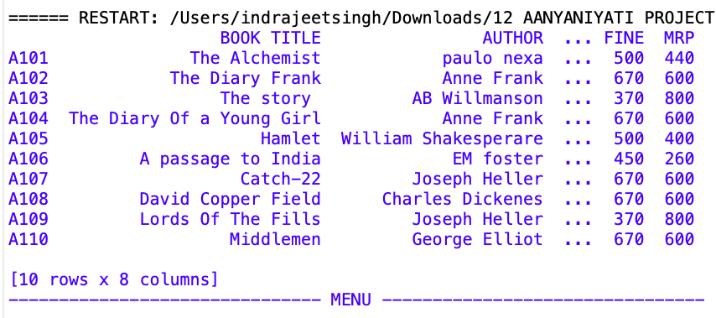

#ADDING ROWS
'''def addrow():
r=input('enter row TO BE ADDED')
l=eval(input('enter row'))
print("**********")
library.loc[r]=l
print('*****row has ben added*****')
print(library.iloc[:,0:4])
print("*******")
print(library.iloc[:,4:])
print('≧▽≦*oヾ')
addrow()'''
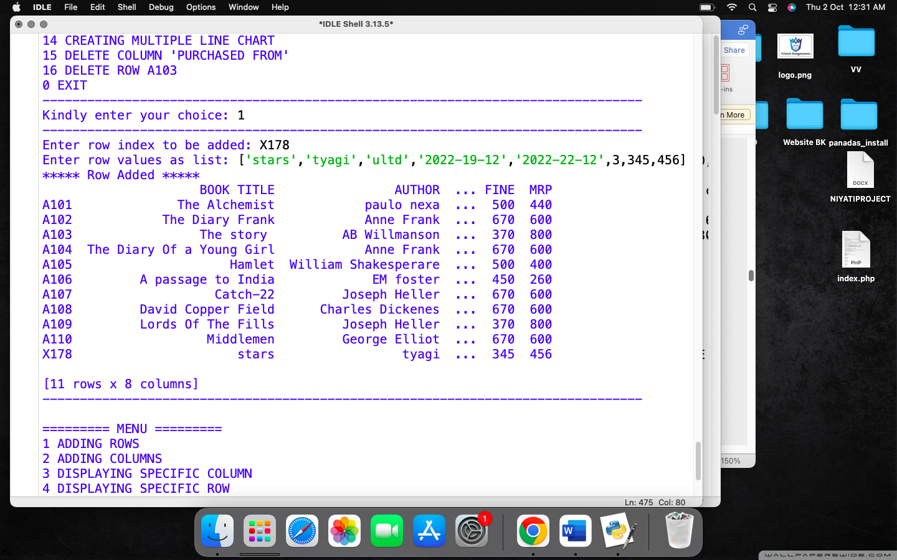

#ADDING COLUMNS
'''def addcolms():
x=input('enter columns to be added')
library[x]=eval(input('enter column value'))
print('______column added successfully________')
print("$$$$$$$$$$$$$$$$$$$")
print(library.iloc[:,0:4])
print("$$$$$$$$$$$$$$$$$$$")
print(library.iloc[:,4:])
print("$$$$$$$$")
addcolms()'''
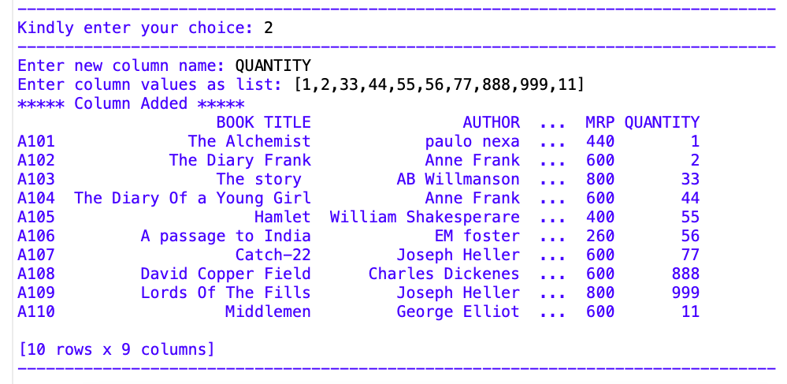

#DISPLAYING SPECIFIC COLUMN
'''def specol():
t=input('enter the column want to be displyed')
print("************************")
print('**********the column wanted is*******')
print(library.loc[:,t])
print('≧▽≦*oヾ')
specol()'''

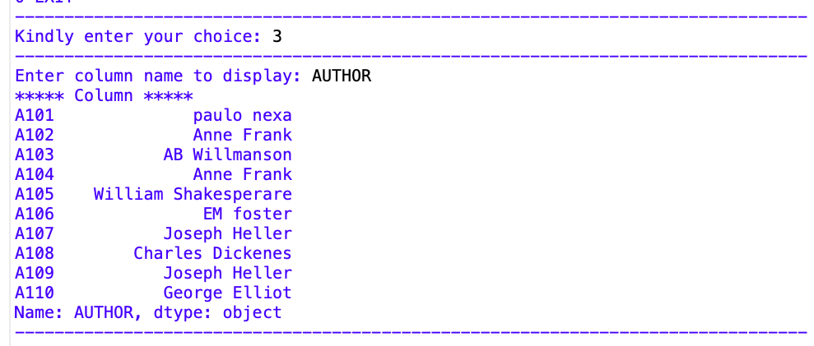

#DISPAYING SPECIFIC ROW
'''def sperow():
z=input('%%%%%%%%%%%enter the row want to be displyed%%%%%%%%%%%')
print("%%%%%%%%%%%%%%%%")
print('the row wanted is')
print("%%%%%%%%%%%%%%%%%%%")
print(library.loc[z,:])
print("%%%%%%%%%%%%%%%%%%%%%")
print('≧▽≦*oヾ')
sperow()'''
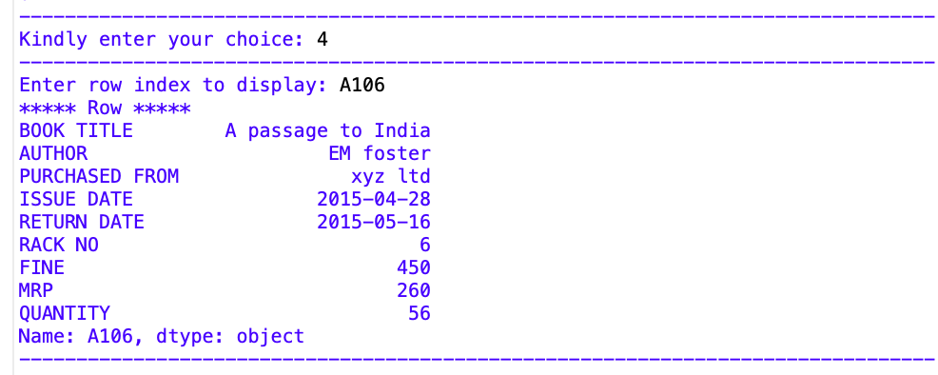

#DELETING COLUMN "PURCHASED FROM
'''del library['PURCHASED FROM']
print(library.iloc[:,0:4])
print(library.iloc[:,4:])
print('≧▽≦*oヾ')'''
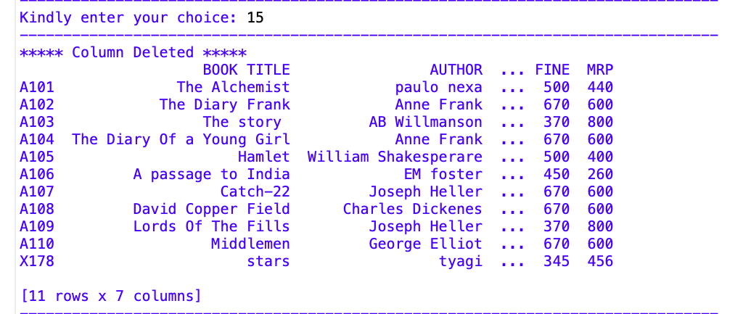

#DELETING SECOND ROW
'''library=library.drop(['A103'])
print(library.iloc[:,0:4])
print(library.iloc[:,4:])
print('≧▽≦*oヾ')
'''
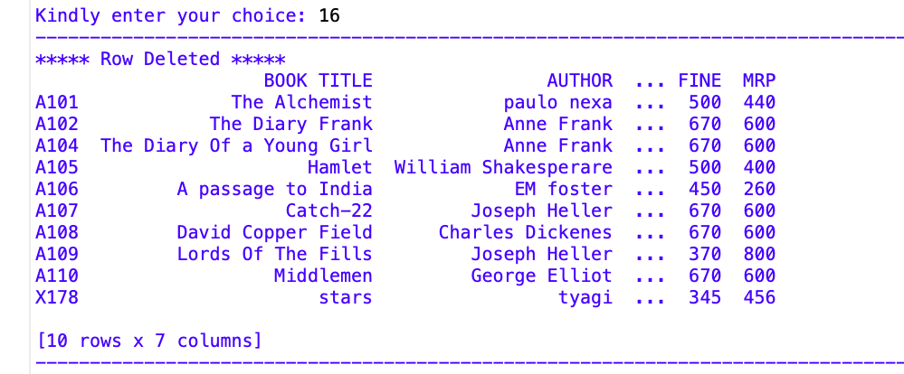

#MODIFYING A SINGLE CELL
def sc():
x=input('the row index to be modified')
y=input('enter the column index to be modified')
print("@@@@@@@@@@@@@@@@@@@")
library.at[x,y]='RUSKIN BOND'
print("the cell is changed ")
print(library.iloc[:,0:4])
print(library.iloc[:,4:])
print('≧▽≦*oヾ')
sc()

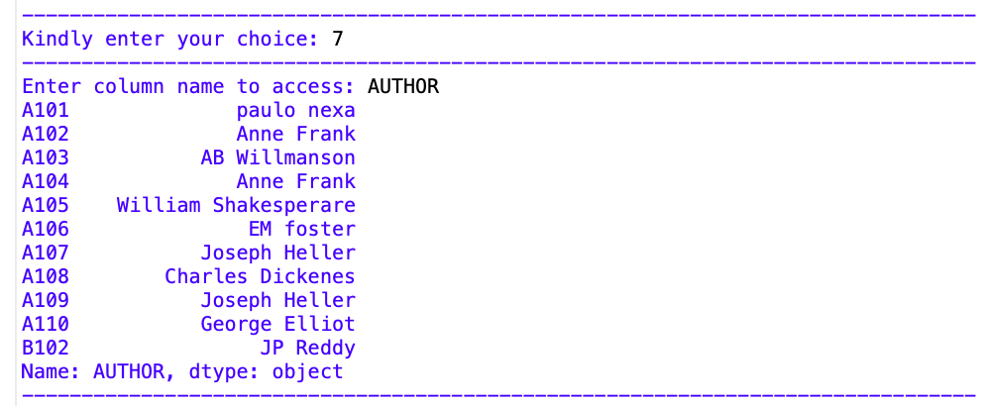

#ADDING A ROW
'''def roww():
q=input('enter a row index to be added')
p=('lucifer','jp reddy','fakir store','2022-02-14','2024-01-02',4,500,430)
library.loc[q]=p
print(library.iloc[:,0:4])
print(library.iloc[:,4:])
print('≧▽≦*oヾ')
roww()'''
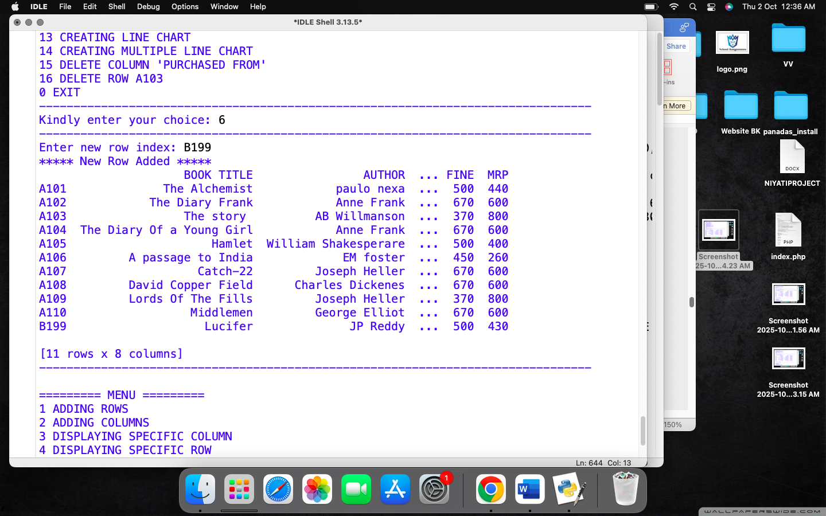

#ACCESSING COLUMN USING LOC
def cmn():
y=input('enter the column which is to be accessed')
print(library.loc[:,y])
print('the column is accessed ')
print("*******************")
cmn()
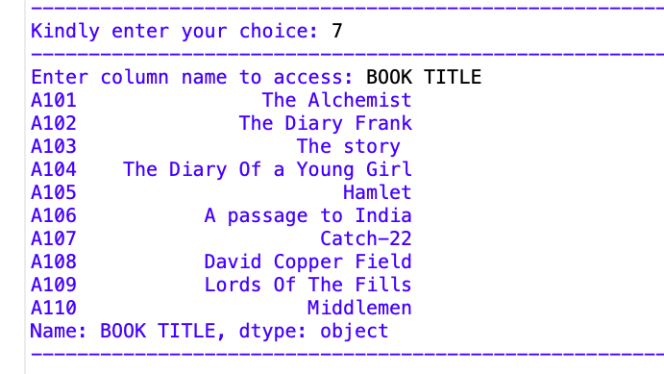

#TO FIND OUT THE SUM
'''def sum():
a=input('enter the column which is to be added')
print(library[a].sum())
print('the sum is')
print('##########################################')
print('≧▽≦*oヾ')
sum()'''
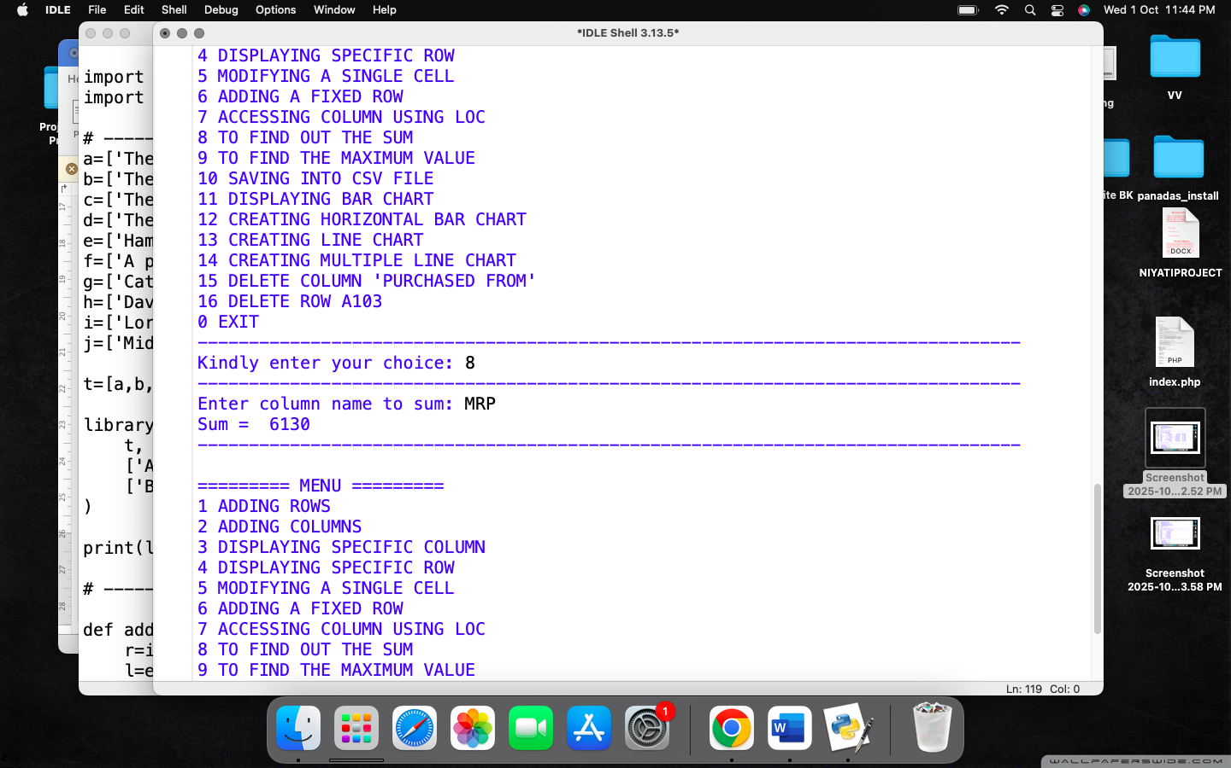

#TO FIND THE MAXIMUM VALUE ROW WISE
'''def max():
q=input('enter the column whose max value is to be found')
print(library[q].max())
print('≧▽≦*oヾ')
max()'''
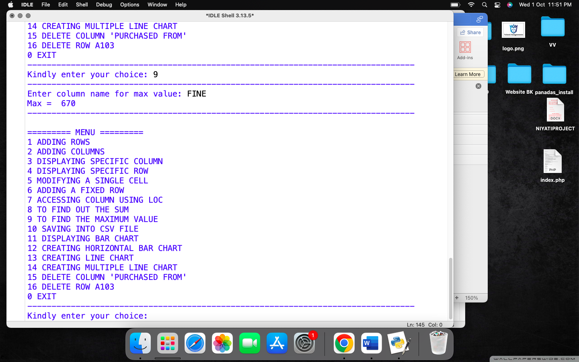
#SAVING INTO CSV FILE
'''def save():
filename=input('enter the file name to be saved')
library.to_csv(filename)
print('csv has been saved')
save()'''
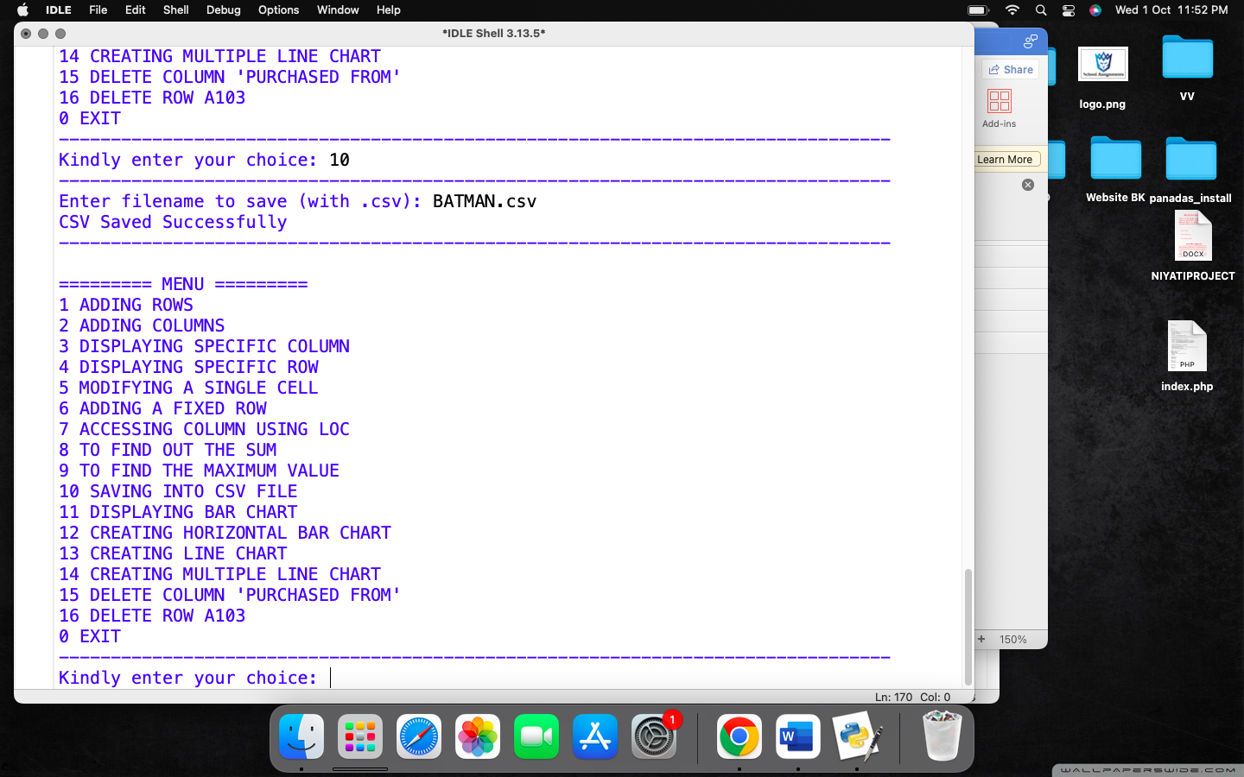

#DISPLAYING BAR CHART
'''import matplotlib.pyplot as plt
def barchart():
x=library['BOOK TITLE']
y=library['RACK NO']
plt.bar(x,y,color='yellow',width=0.4)
plt.xlabel('BOOK TITLE')
plt.ylabel('RACK NO')
plt.show()
barchart()'''
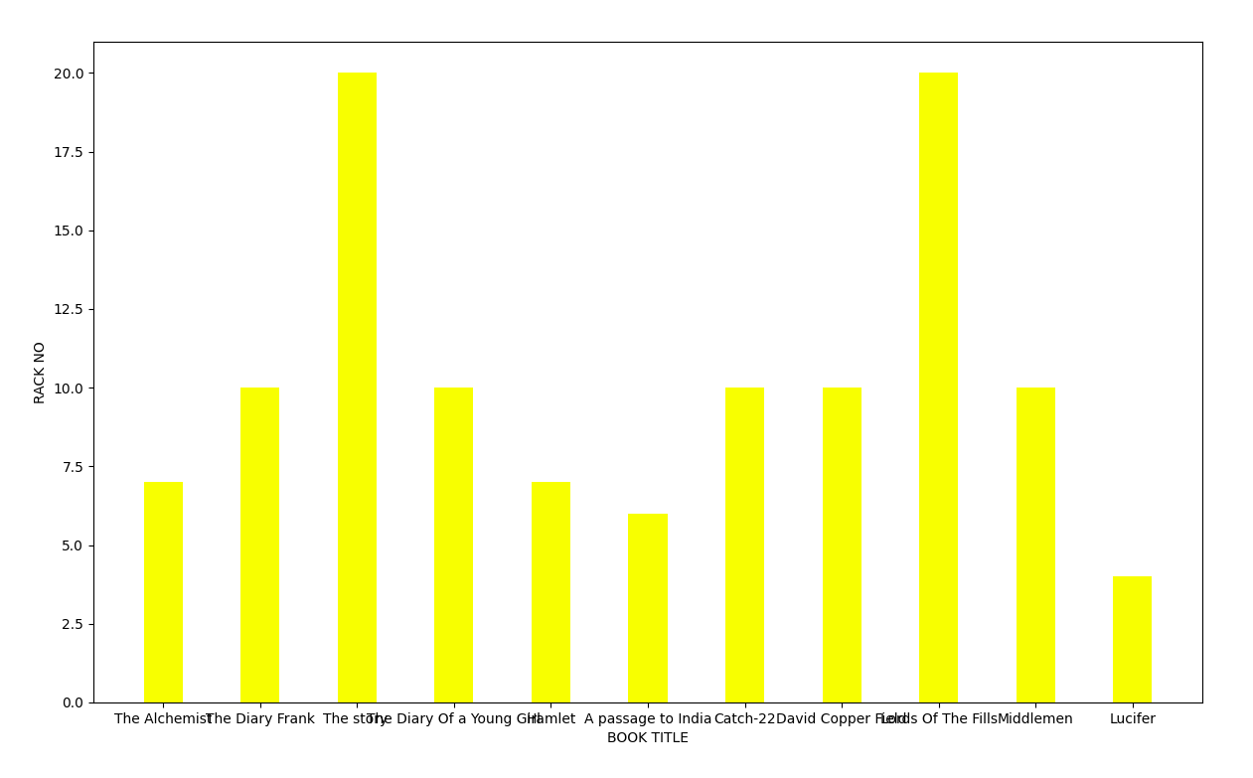
#DISPLAYING HORIZONTAL BAR CHART
def hbar():
w=library['AUTHOR']
x=library['MRP']
plt.barh(w,x,color='green',height=0.5)
plt.xlabel('Prices of the book')
plt.ylabel('Name of the author')
plt.title('Record of Book')
plt.show()
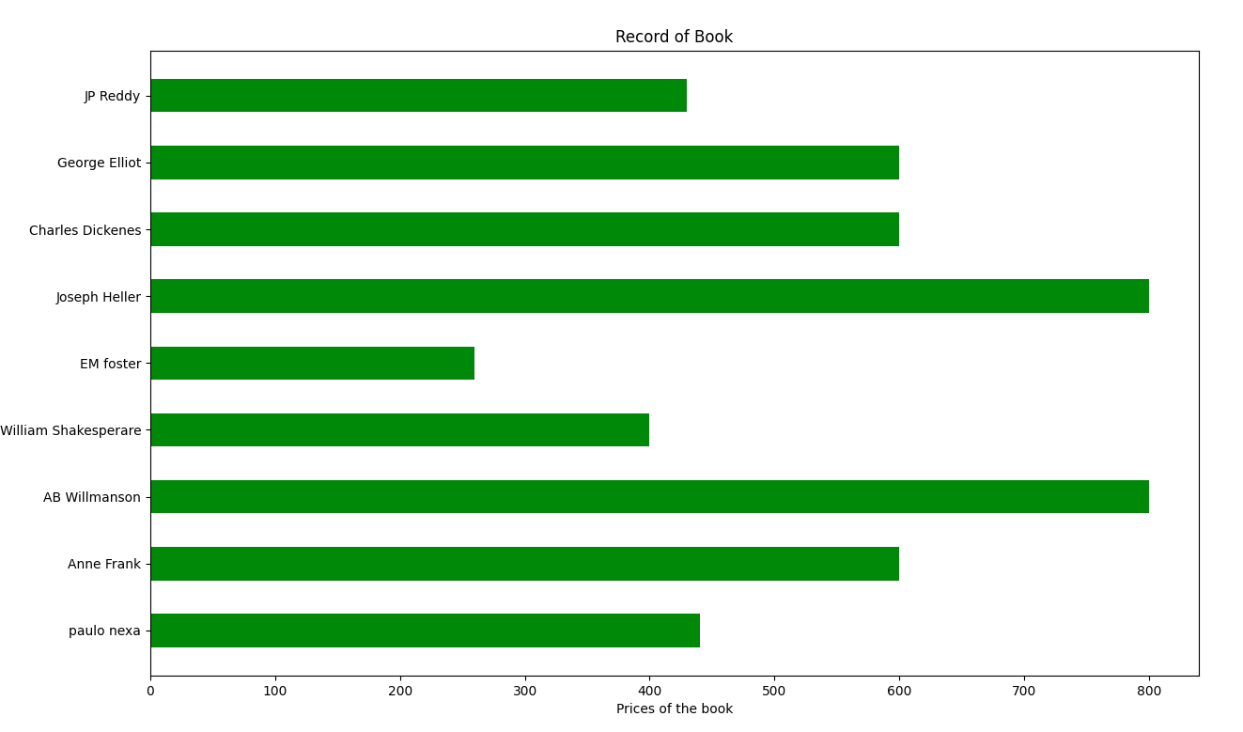
#DISPLAYING LINE CHART

def linec():
n=library['AUTHOR']
s=library['FINE']
plt.plot(n,s,color='teal',linestyle='dashdot',marker='*',markeredgecolor='b')
plt.xlabel('Authors')
plt.ylabel('Fine amount')
plt.show()
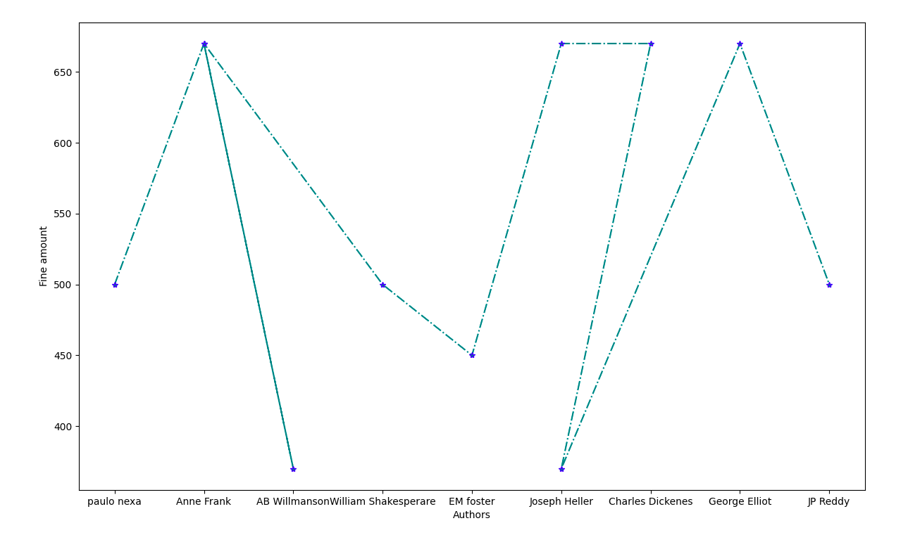
#DISPLAYING MULTIPLE LINE CHART
def mline():
x=library['BOOK TITLE']
w=library['RACK NO']
y=library['FINE']
plt.plot(x,w,color='g',linestyle='dashed',label="Rack No")
plt.plot(x,y,color='r',linestyle='dashdot',label="Fine")
plt.grid(True)
plt.xlabel('Book Title')
plt.ylabel('RackNo / Fine')
plt.legend()
plt.show()
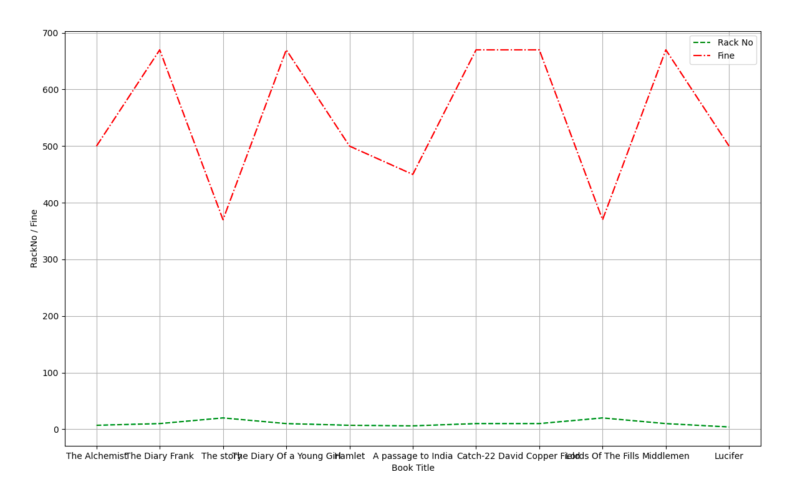
#DELETING COLUMNS
def delcol():
if 'PURCHASED FROM' in library.columns:
del library['PURCHASED FROM']
print("***** Column Deleted *****")
print(library)
else:
print("Column already deleted!")
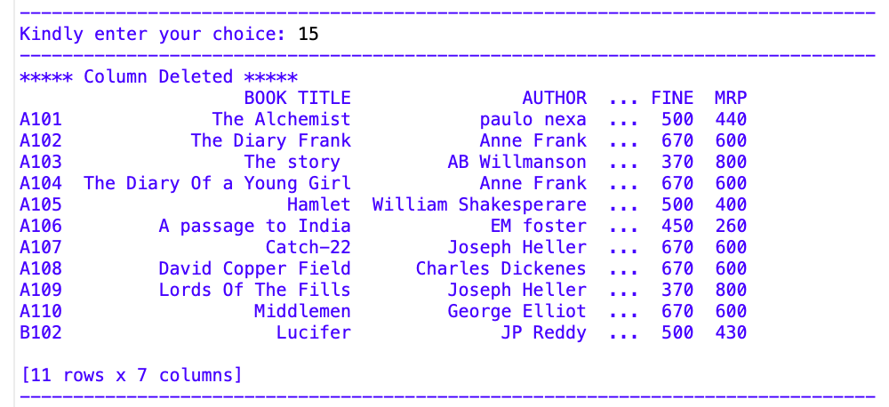
#DELETING ROWS
def delrow():
if 'A103' in library.index:
library.drop(['A103'], inplace=True)
print("***** Row Deleted *****")
print(library)
else:
print("Row already deleted!")
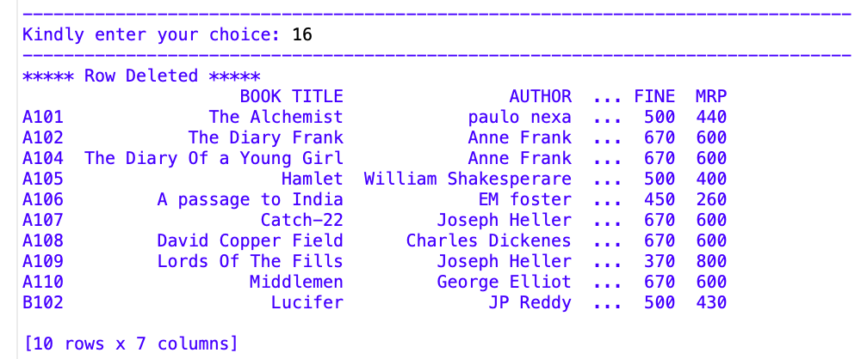

print("------------------------------- MENU --------------------------------")
while True:
print("--------------------------------------------------------------------------------")
print("\n========= MENU =========")
print("1 ADDING ROWS")
print("2 ADDING COLUMNS")
print("3 DISPLAYING SPECIFIC COLUMN")
print("4 DISPLAYING SPECIFIC ROW")
print("5 MODIFYING A SINGLE CELL")
print("6 ADDING A FIXED ROW")
print("7 ACCESSING COLUMN USING LOC")
print("8 TO FIND OUT THE SUM")
print("9 TO FIND THE MAXIMUM VALUE")
print("10 SAVING INTO CSV FILE")
print("11 DISPLAYING BAR CHART")
print("12 CREATING HORIZONTAL BAR CHART")
print("13 CREATING LINE CHART")
print("14 CREATING MULTIPLE LINE CHART")
print("15 DELETE COLUMN 'PURCHASED FROM'")
print("16 DELETE ROW A103")
print("0 EXIT")
print("--------------------------------------------------------------------------------")
ans=int(input("Kindly enter your choice: "))
print("--------------------------------------------------------------------------------")
if ans==1:
addrow()
elif ans==2:
addcolms()
elif ans==3:
specol()
elif ans==4:
sperow()
elif ans==5:
sc()
elif ans==6:
roww()
elif ans==7:
cmn()
elif ans==8:
sumcol()
elif ans==9:
maxcol()
elif ans==10:
save()
elif ans==11:
barchart()
elif ans==12:
hbar()
elif ans==13:
linec()
elif ans==14:
mline()
elif ans==15:
delcol()
elif ans==16:
delrow()
elif ans==0:
print("Exiting... Bye!")
break
else:
print("Invalid choice, try again!")

print("--------------------------------------------------------------------------------")

